**Task 5 – Kubernetes Deployment on Cloud (Screenshots)**

This document contains all the relevant screenshots captured during the execution of **Task 5**, where we deployed a sample web application using Kubernetes on a cloud-based virtual machine (Azure VM). Each step, from setting up the environment to accessing the deployed app in a web browser, is documented visually to support and validate the task completion.

1.Installed the docker

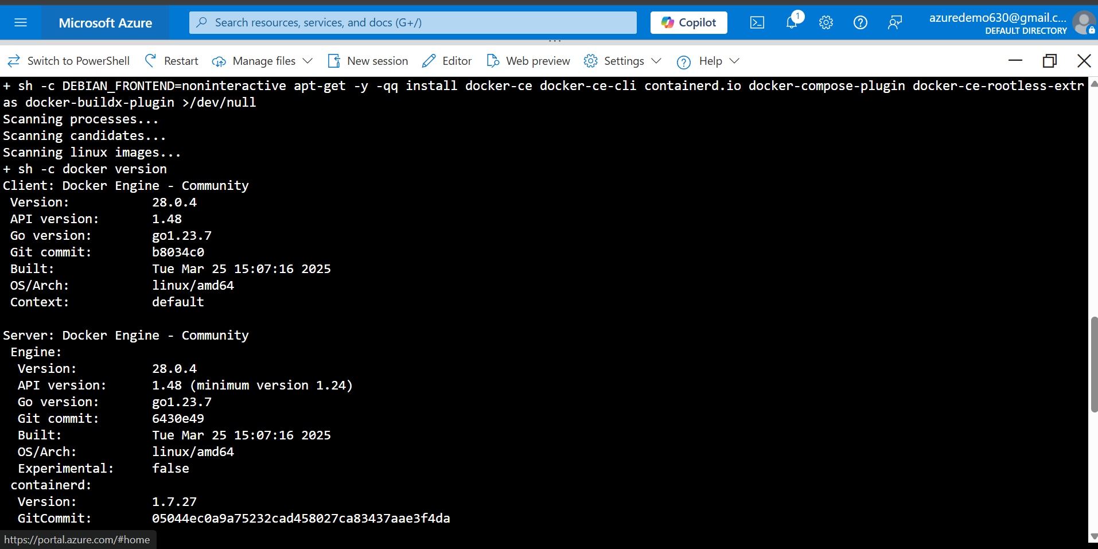

2.Minikube and Kubectl installation

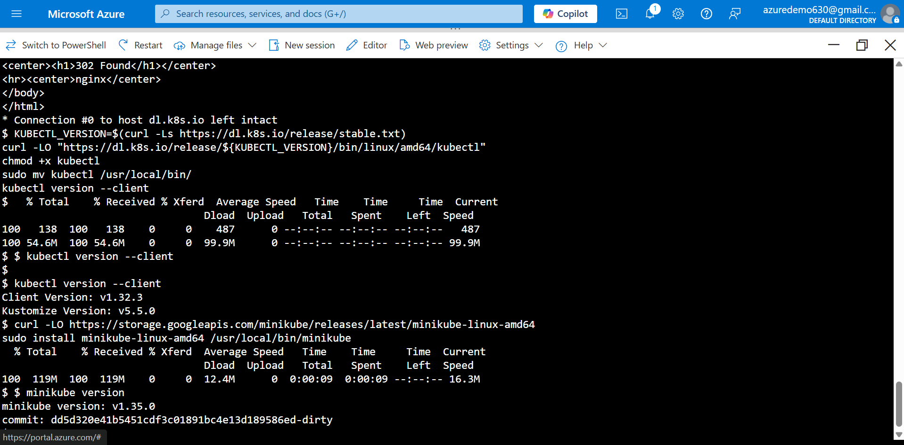

3.Started the Minikube

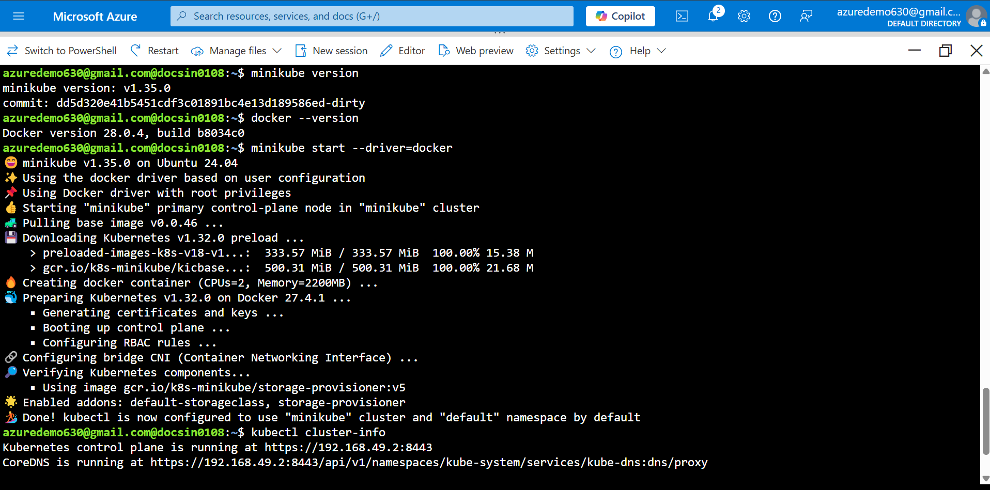

4.Pod Info

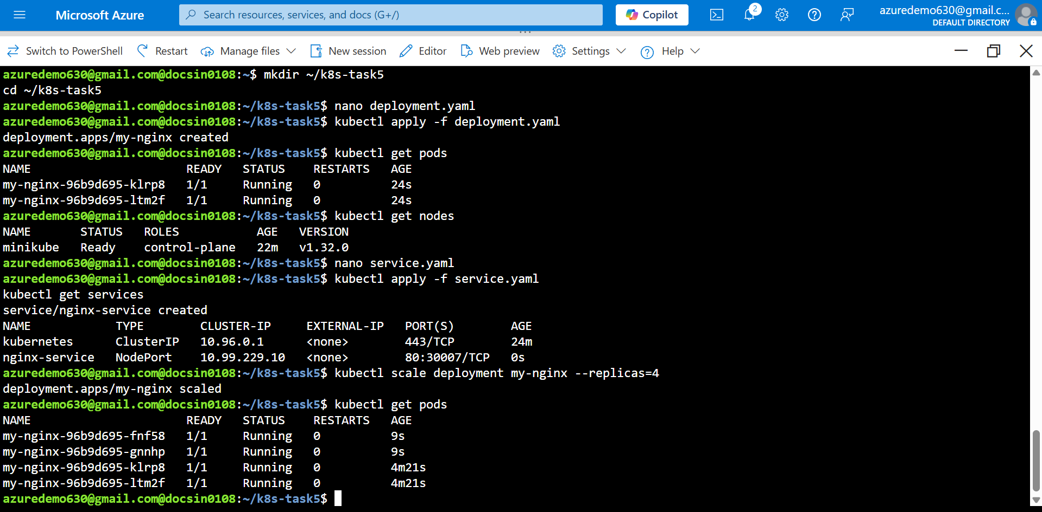

5.Accessing log using Kubectl describe

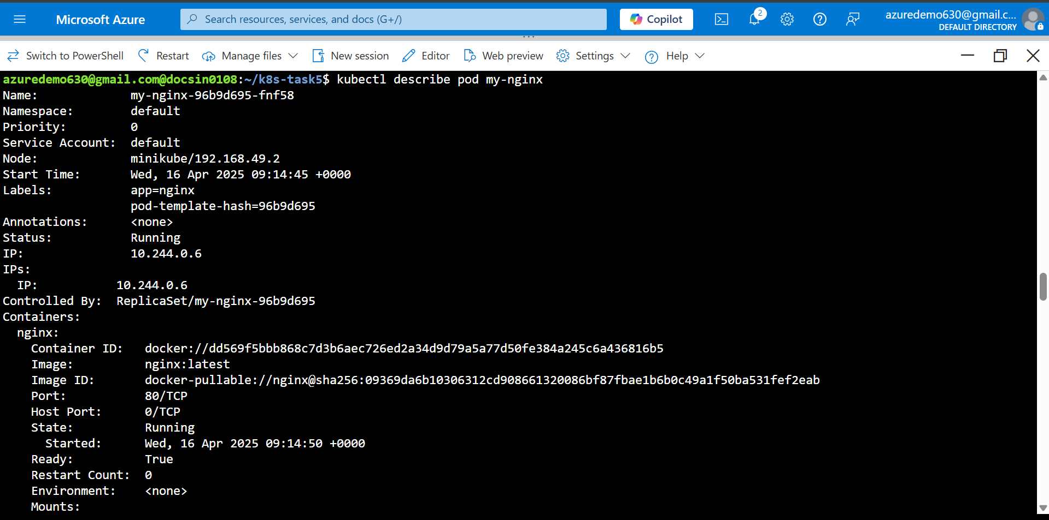

6.Accessing the website using vm ip

